

**Polling District and Polling Place Review 2025**

**Dene and South Gosforth Ward**

**Parliamentary Constituency:** North

**(Proposed) Polling Districts:** G01, G02, G03, G04, G05

The Local Government Boundary Commission for England are an independent body accountable to Parliament. They are responsible for reviewing councils to make sure their patterns of internal wards are fair and sensible. Their reviews include at least two rounds of public consultation before they make recommendations for change.

The final recommendations were published on 7 January 2025, and the new arrangements apply to local elections from 2026.

As a result of changes to ward boundaries the Acting Returning Officer (ARO) is conducting a review of polling districts and polling places to ensure that they are suitable for the new ward boundaries.

For more information on the local government boundary review visit: <https://www.lgbce.org.uk/all-reviews/newcastle-upon-tyne>

This document provides details of the review, along with the initial recommendations and comments of the Acting Returning Officer (ARO). Also, the election rules require the ARO to decide how many polling stations are required for each polling station and the ARO must allocate electors to the polling stations in such manner as they think most convenient.

These recommendations will be open to all residents, stakeholders, and any interested parties. We shall be seeking representations from local disability groups on the accessibility and suitability of polling places. Any comments should be addressed in the first instance to pollingplaces@newcastle.gov.uk where they will be collated on behalf of the (Acting) Returning Officer.

We considered the following factors:

* **Identifying new polling places:** We will look for new polling places in areas where the existing provision is unsuitable or unavailable.
* **Feedback:** We will consider feedback received following recent elections, consultation from members of the public, elected members, and other stakeholders.
* **Accessibility:** We will try to ensure that every polling place is accessible to electors with disabilities.
* **Facilities**: We will make sure that all electors have such reasonable facilities for voting as are practicable in the circumstances.
* **Elector numbers:** We will try to comply with the Electoral Commission guidance on the maximum number of electors that should be allocated to a polling station which should not exceed 2,250.
* **Future housing developments**: We will consider the impact of proposed housing developments on polling station electorates.

**(Current) Dene and South Gosforth Ward**

This map shows the current ward and polling district boundaries and the polling places.

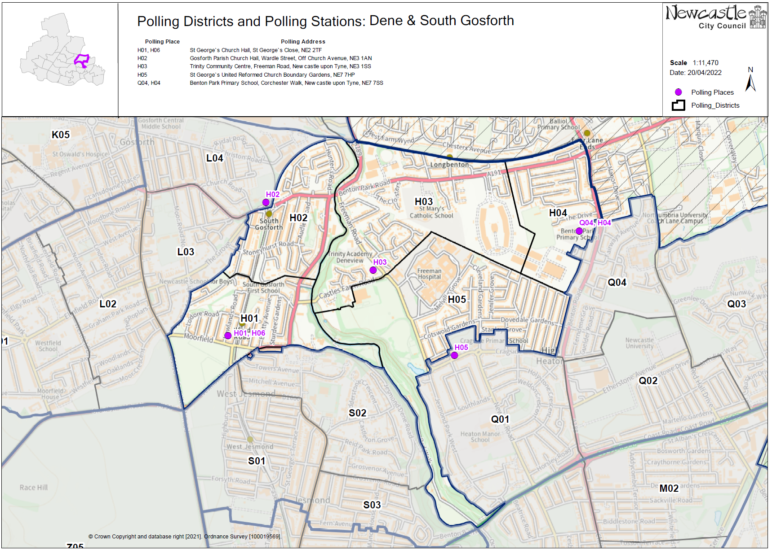

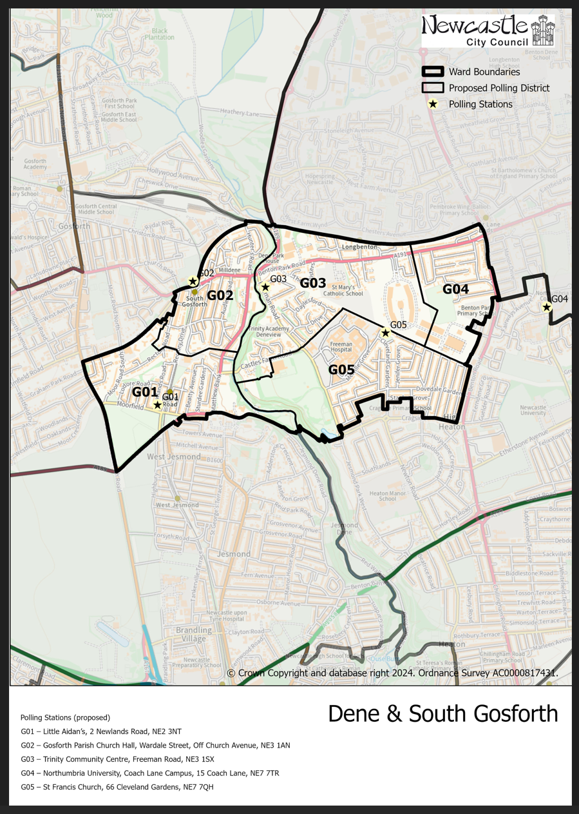**(New)**

**Dene and South Gosforth Ward**

This map shows the new ward and the proposed polling districts and the proposed polling places.

* G01 – Little Aidan’s, 2 Newlands Road, NE2 3NT
* G02- Gosforth Parish Church Hall, Wardale Street, Off Church Avenue, NE3 1AN
* G03 – Trinity Community Centre, Freeman Road, NE3 1SX
* G04 – Northumbria University, Coach Lane Campus, 15 Coach Lane, NE7 7TR
* G05 – St Francis Church, 66 Cleveland Gardens, NE7 7QH

**Dene and South Gosforth Ward**

**Polling District G01**

|  |  |
| --- | --- |
| **Current Polling District** | **Current Polling Place** |
| H01 (full)  H06 (full)  L03 (part of) | St George’s Church Hall, St George’s Close, NE2 2TF  St George’s Church Hall, St George’s Close, NE2 2TF  South Northumberland Cricket Club, Roseworth Terrace, NE3 1LU |

|  |  |  |
| --- | --- | --- |
| **Proposed**  **Polling District** | **Predicted**  **Polling Station Electorate** | **Proposed**  **Polling Place** |
| G01 | 957 | Little Aidan’s, 2 Newlands Road, NE2 3NT |

|  |
| --- |
| **Considerations and Proposals** |
| Merge current H01, H06 and part of L03 to create the proposed G01 district. Incorporates a small number of properties to the west of Moor Road South from the current L03 district and a small number from the current H06 district.  South Gosforth First School was considered, however the school raised concerns around lack of space and security issues.  Little Aidan’s is the proposal for this district. It is within the district boundary and is happy to be used. A site visit was carried out on 11 August 2025 to ensure that accessibility requirements are met. |

|  |
| --- |
| **Preliminary Consultation – Elected Members comments and feedback** |
| Ward councillor has expressed an interest in using South Gosforth First School as a polling station. School has raised some concerns with regards to being used as a polling station, namely, lack of space and security.  Councillor Wendy Taylor has no problems with the suggestions. |

**Dene and South Gosforth Ward**

**Polling District G02**

|  |  |
| --- | --- |
| **Current Polling District** | **Current Polling Place** |
| H02 (full) | Gosforth Parish Church Hall, Wardale Street, Off Church Avenue, NE3 1AN |

|  |  |  |
| --- | --- | --- |
| **Proposed Polling District** | **Predicted**  **Polling Station Electorate** | **Proposed Polling Place** |
| G02 | 1237 | Gosforth Parish Church Hall, Wardale Street, Off Church Avenue, NE3 1AN |

|  |
| --- |
| **Considerations and Proposals** |
| Current H02 is now the proposed G02. No changes to the polling district.  The Brandling Villa Pub is a consideration depending on a site visit.  If not, the Gosforth Parish Church Hall will continue to be used, however this is outside of the district. |

|  |
| --- |
| **Preliminary Consultation – Elected Members comments and feedback** |
| Councillor Wendy Taylor has no problems with the suggestions. |

**Dene and South Gosforth Ward**

**Polling District G03**

|  |  |
| --- | --- |
| **Current Polling District** | **Current Polling Place** |
| H03 (full) | Trinity Community Centre, Freeman Road, NE3 1SX |

|  |  |  |
| --- | --- | --- |
| **Proposed**  **Polling District** | **Predicted**  **Polling Station Electorate** | **Proposed**  **Polling Place** |
| G03 | 806 | Trinity Community Centre, Freeman Road, NE3 1SX |

|  |
| --- |
| **Considerations and Proposals** |
| Current H03 is the proposed G03. No changes to the polling district.  No change to the polling place. |

|  |
| --- |
| **Preliminary Consultation – Elected Members comments and feedback** |
| Councillor Wendy Taylor has no problems with the suggestions. |

**Dene and South Gosforth Ward**

**Polling District G04**

|  |  |
| --- | --- |
| **Current Polling District** | **Current Polling Place** |
| H04 (full) | Benton Park Primary School, Corchester Walk, NE7 7SS |

|  |  |  |
| --- | --- | --- |
| **Proposed Polling District** | **Predicted**  **Polling Station Electorate** | **Proposed Polling Place** |
| G04 | 470 | Northumbria University, Coach Lane Campus, 15 Coach Lane, NE7 7TR |

|  |
| --- |
| **Preliminary Consultation – Elected Members comments and feedback** |
| **Cllr Wendy Taylor**  “Your suggestion for G04 (Benton Lodge area) isn’t in the polling district or even in Dene and South Gosforth ward so I don’t understand why it has been suggested”.  “Perhaps we could look at a shop at Four Lane Ends or Sutherland Park Rugby Club (Disabled access could be a problem there). Otherwise, would a portacabin not be possible as a temporary measure”. |

|  |
| --- |
| **Considerations and Proposals** |
| Current H04 would be the proposed G04. No changes to the polling district.  The existing polling place is Benton Park Primary School, which is currently closed for refurbishment.  Northumbria University is the suggested polling station for this district, to be used as a double polling station for the proposed G04 and Q04 districts.  Another proposal is Novocastrians RFC. Site visit required. |

**Dene and South Gosforth Ward**

**Polling District G05**

|  |  |
| --- | --- |
| **Current Polling District** | **Current Polling Place** |
| H05 (full) | St George’s United Reformed Church, Boundary Gardens, NE7 7HP |

|  |  |  |
| --- | --- | --- |
| **Proposed Polling District** | **Predicted**  **Polling Station Electorate** | **Proposed Polling Place** |
| G05 | 1197 | St Francis Church, 66 Cleveland Gardens, NE7 7QH |

|  |
| --- |
| **Considerations and Proposals** |
| Current H05 is now the proposed G05.  Loses part of the district to the new Manor Park ward, mainly consisting of Jesmond Dene.  St Francis Church is the suggested polling station for this district. Site visit required. |

|  |
| --- |
| **Preliminary Consultation – Elected Members comments and feedback** |
| Councillor Wendy Taylor has no problems with the suggestions. |